REREFENCE INFORMATION

https://www.idealvac.com/Stainless-Steel-Vacuum-Tubing-60-in-OD-x-0109/pp/P106598

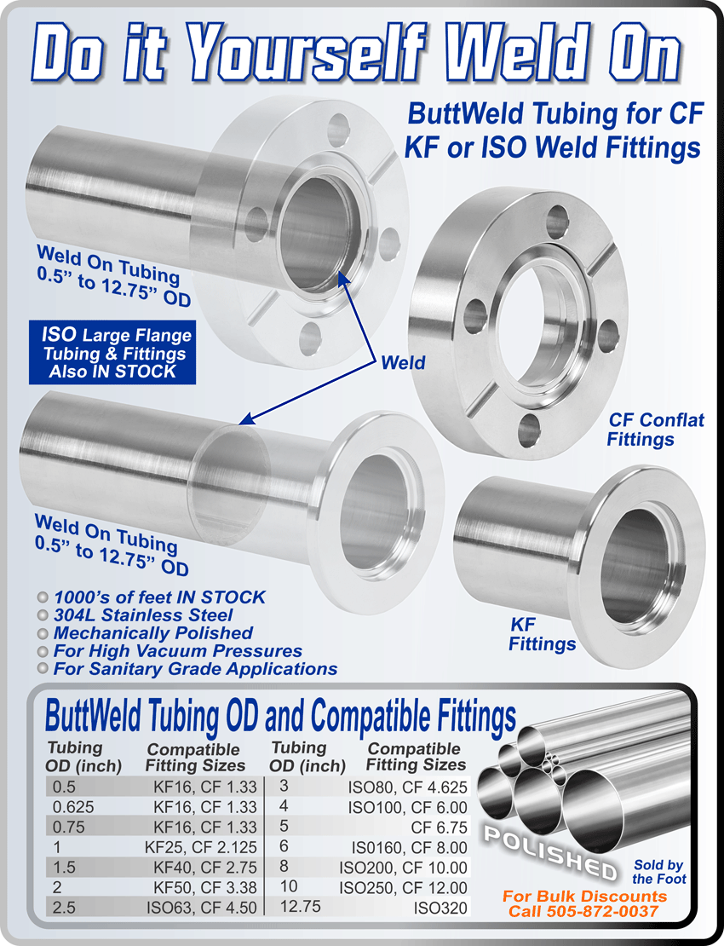

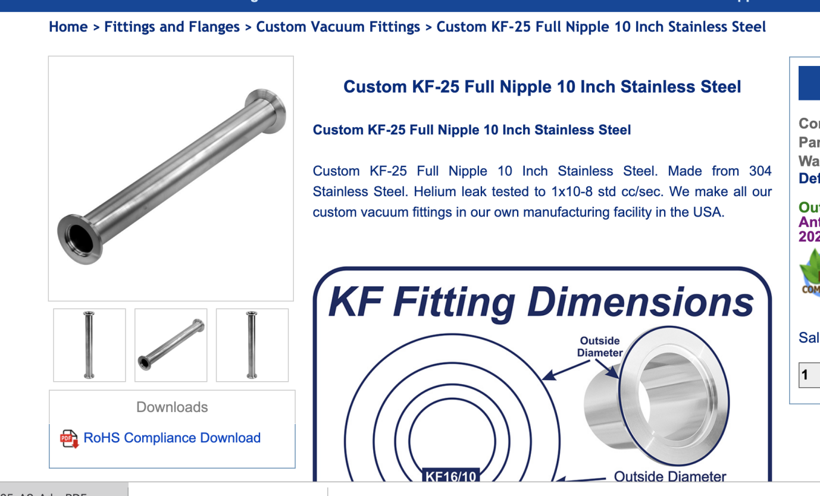

https://www.idealvac.com/Custom-KF-25-Full-Nipple-10-Inch-Stainless-Steel/pp/P1010058

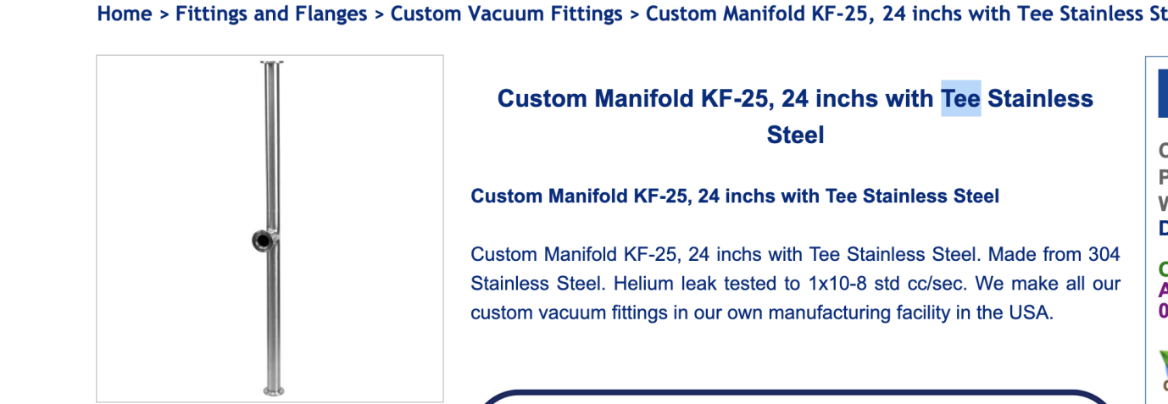

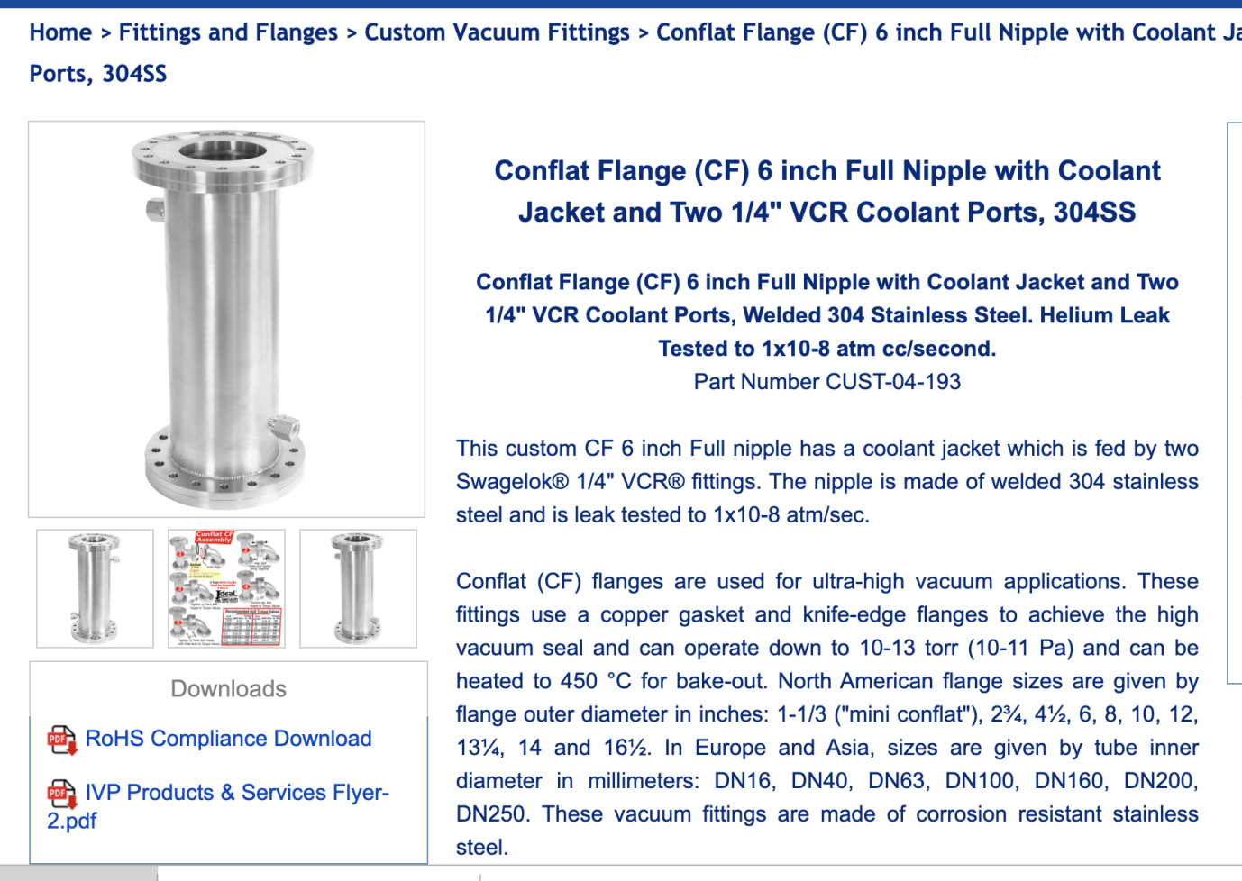
https://www.idealvac.com/Conflat-Flange-(CF)-6-inch-Full-Nipple-with-Coolant-Jacket-and-Two-14-VCR-Coolant-Ports/pp/P1011593

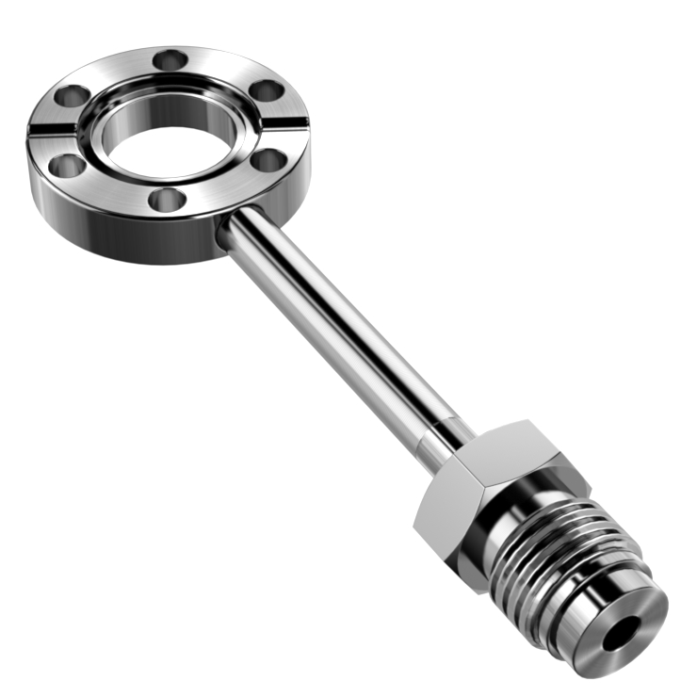

Sideported Conflat Flange (CF) 1-1/3 inch, 0.63, connected to Male Swagelok 1/4 inch Stainless Steel VCR Fitting

Sideported Conflat Flange (CF) 1-1/3 inch, 0.63, connected to Male Swagelok 1/4 inch Stainless Steel VCR Fitting
These Sideported Conflat to Swagelok® vacuum fittings have a flange size of ConFlat (CF) 1-1/3 inch connected to Swagelok 1/4 inch. ConFlat (CF) flanges are used for ultra-high vacuum applications. These fittings use a copper gasket and knife-edge flanges to achieve the high vacuum seal and can operate down to 10-13 torr (10-11 Pa). They can typically be heated to 450 °C for bake-out. North American flange sizes are given by flange outer diameter in inches: 1-1/3 ("mini conflat"), 2¾, 4½, 6, 8, 10, 12, 13¼, 14 and 16½. In Europe and Asia, sizes are given by flange inner diameter in millimeters: DN16, DN40, DN63, DN100, DN160, DN200, DN250. These vacuum fittings are made of corrosion resistant 316 stainless steel.

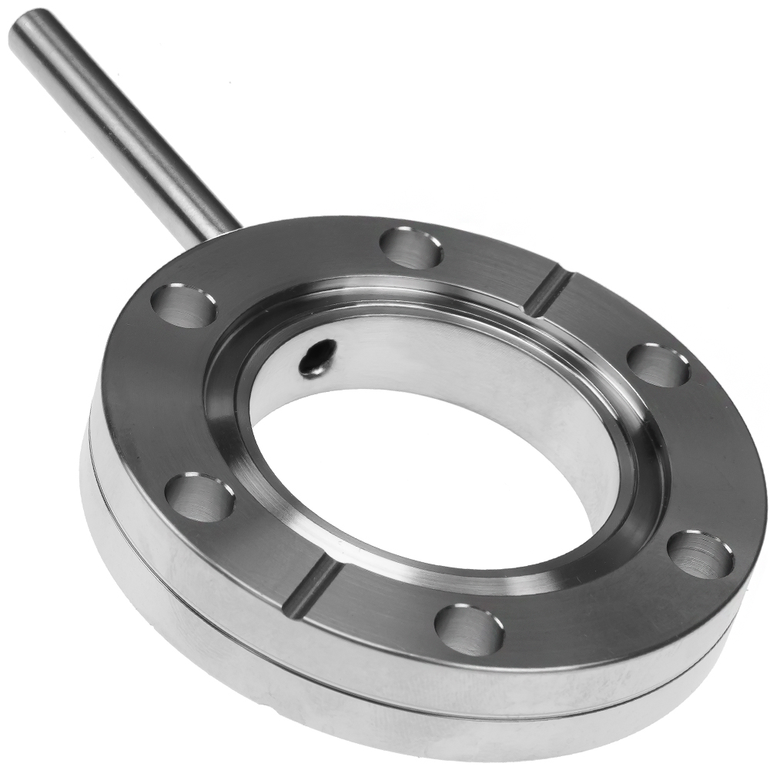

Sideported Flange 2.75 CF to 0.25 in. OD Tube - 304SS

Sideported Flange 2.75 CF Double Sided, Bored 1 1/2 in. - 0.25 in. OD Tube (All Stainless Steel Construction 304SS)

Sideported, zero length flanges can have many uses in your process vacuum line. Because of their excellent rigidity and low profile, they are well suited for mounting, for example, all metal valves in locations where a conventional tee union is impractical. In another application scenario, the area surrounding a process chamber may have many ports, occupied with an array of feedthroughs, hoses, and large sensors making the attachment of anything else a time consuming puzzle. In such cases, a sideported flange can greatly simplify the installation of a gas supply, vent, or pressure sensor. They can, effectively, be used to swap out components without venting the main chamber.
Where vacuum lines must be located to a purpose-specific, common location, these flanges can make it easy to attach gas supply hardware as well as easily accessible pressure monitoring equipment without adding significant length to your line. Manifolds become much simpler affairs to install, monitor, and maintain when footprints are reduced and fittings are minimized. Please note that although these are standard product offerings, we are happy to customize and create any configuration desired. Bore size, tube length, tapped holes, and zero length reducer flanges are all options that can be customized to your application.
● Bored 1.5 in. CF Flange Size: 2.75CF
● Tube Diameter: 0.25 in.
● UHV vacuum rating approx. 1×10⁻¹³ torr
● Temperature range from -200°C to 450°C

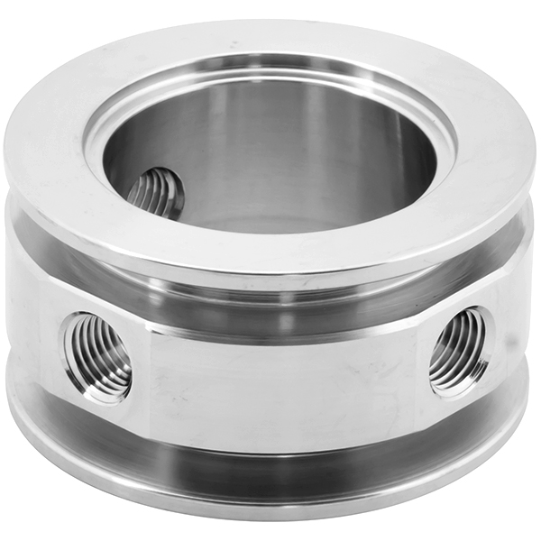

Adapter KF-50 to 1/4 in. Triple NPT-Female, Flange Size ISO-KF NW-50, Stainless Steel

Adapter KF-50 to 1/4 in. Triple NPT-Female, Flange Size ISO-KF NW-50, Stainless Steel

These adapters are KF-50 to 1/4 inch triple NPT-female. They are commonly used to make connections between ISO-KF and 1/4 inch male pipe thread fittings. The ISO-KF flanges are often called quick flange fittings because they are quick to assemble. A circumferential clamp and centering ring form the vacuum seal between the connecting flanges (please see top right figure - click to enlarge). The centering ring contains a rubber elastomer o-ring. The standard sizes for quick flange fittings are KF-10, KF-16, KF-25, KF-40, and KF-50 with flange sizes NW-10, NW-16, NW-25, NW-40, and NW-50, respectively. They are made of corrosive resistant stainless steel.
Adapter KF-50 to 1/4 in. Triple NPT-female, Flange Size ISO-KF NW-50, Stainless Steel
Flange Size: ISO-KF NW-50
Pipe Thread: 1/4 in. NPT-Female
Common Dimensions:
A = 0.76" (19mm)
B = 1.57" (40mm)
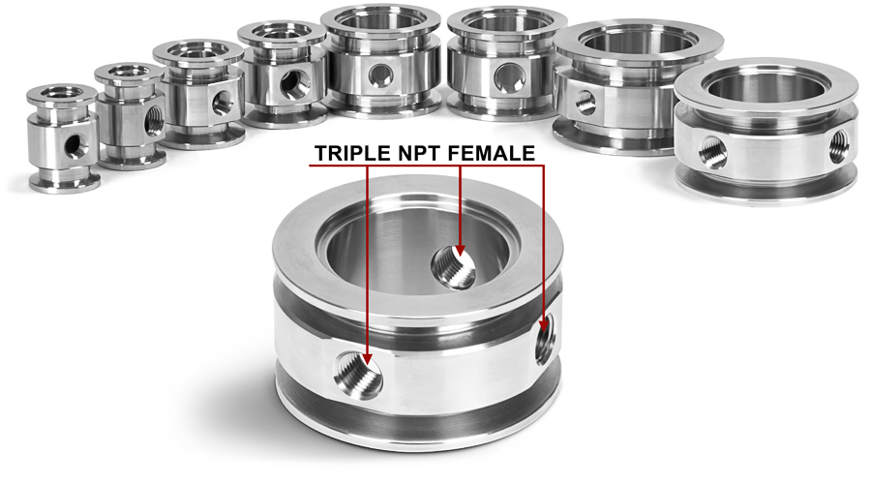

Sanitary Fittings

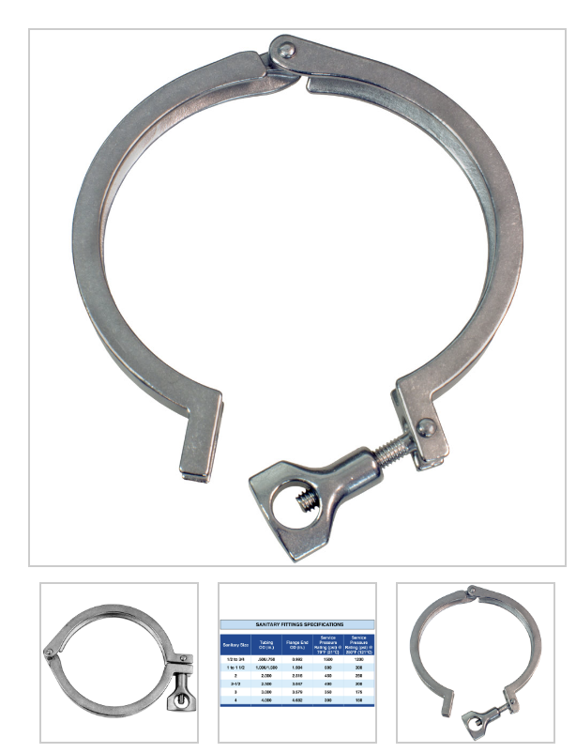

Tri-Clamp for 4" Sanitary Tubing, 304 Stainless Steel

Tri-Clamp for 4" Sanitary Tubing, 304 Stainless Steel

These single-pin, heavy duty tri-clamps are used for 4" sanitary tube fittings. These clamps are made of 304 stainless steel.
Tri-clamps are used to quickly join sanitary fittings used in process line equipment in the food, beverage and biopharmaceutical industries.
Sanitary fittings are measured from the outside diameter of the sanitary tubing, not the inside or outside diameter of the sanitary flange. Please see the second image for dimensions.
Tri-clamp connections require a gasket (sold separately) to make a leak-proof seal. They are tightened by hand. We recommend tightening the wingnut until snug, then rotating an additional ½ to full turn. Overtightening will not improve the seal and can damage the gasket or tubing flange.

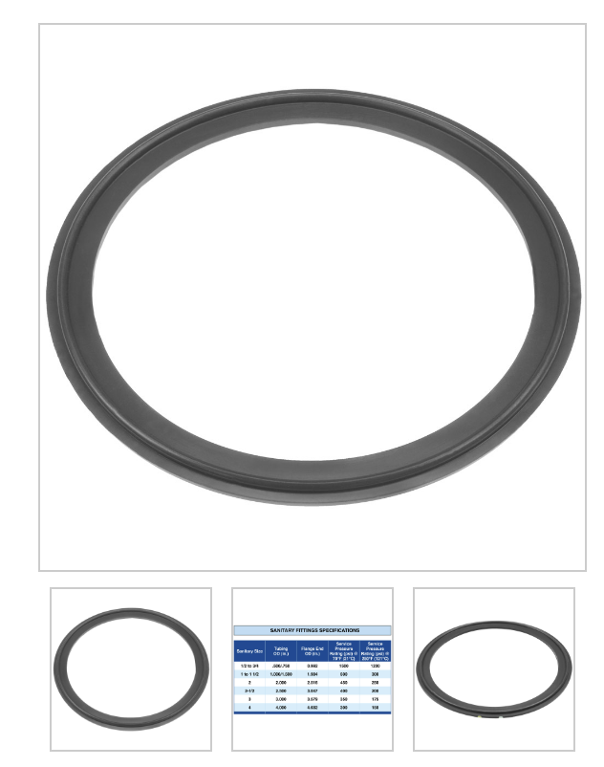

Tri-Clamp Gasket for 4" Sanitary Tubing Fittings, Viton

Tri-Clamp Gasket for 4" Sanitary Tubing Fittings, Viton

These Tri-clamp gaskets are used to create leak-proof seals when connecting 4" sanitary tubing fittings. They are made of Viton®, an FKM which is chemically and temperature resistant.
Tri-clamps are used to quickly join sanitary fittings used in process line equipment in the food, beverage and biopharmaceutical industries.
Sanitary fittings are measured from the outside diameter of the sanitary tubing, not the inside or outside diameter of the sanitary flange. Please see the second image for dimensions.
Tri-clamps are tightened by hand. We recommend tightening the wingnut until snug, then rotating an additional ½ to full turn. Overtightening will not improve the seal and can damage the gasket or tubing flange.

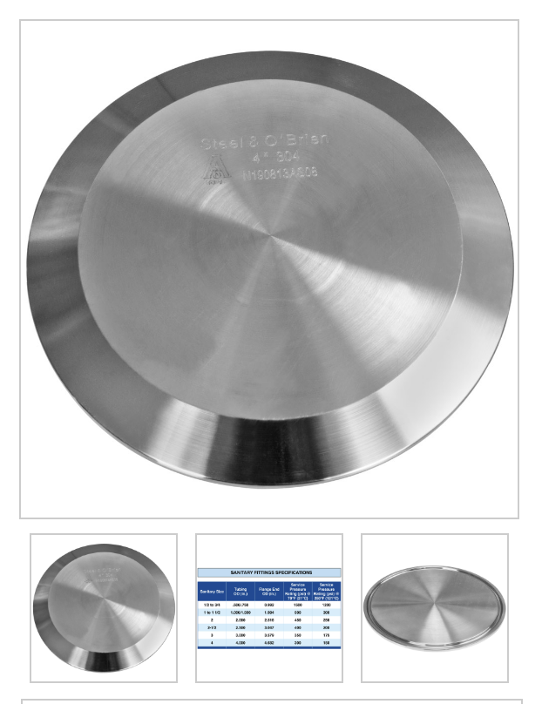

Tri-Clamp Blank Flange (Cap) for 4" Sanitary Tubing Fittings, 304 Stainless Steel

Tri-Clamp Blank Flange (Cap) for 4" Sanitary Tubing Fittings, 304 Stainless Steel

These Tri-clamp caps/blank flanges, made of 304 stainless steel, are used to terminate 4" sanitary tubing fittings . With proper Tri-clamp gaskets, they will produce a leak-proof seal at the end of the process line.
Tri-clamps are used to quickly join sanitary fittings used in process line equipment in the food, beverage and biopharmaceutical industries.
Sanitary fittings are measured from the outside diameter of the sanitary tubing, not the inside or outside diameter of the sanitary flange. Please see the second image for dimensions.
Tri-clamps are tightened by hand. We recommend tightening the wingnut until snug, then rotating an additional ½ to full turn. Overtightening will not improve the seal and can damage the gasket or tubing flange.
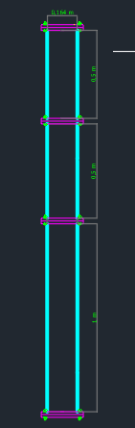

Tri Clamp 304 Stainless Fits Sankey Keg
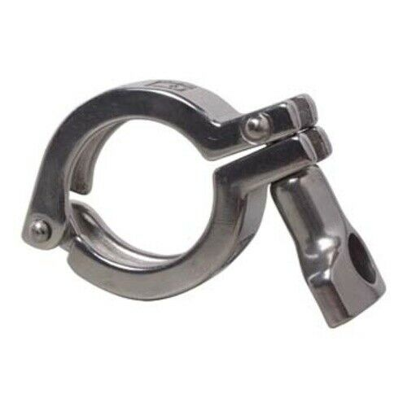
2 PACK 2" Silicone Tri Clamp BEER KEG GASKET For Distilling Column Moonshine
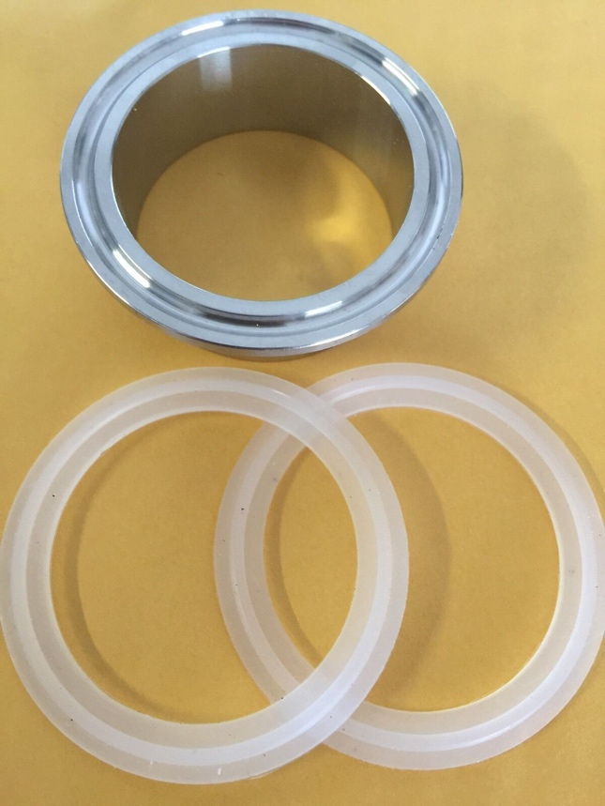

2" Copper Tri Clamp Ferrule Beer Keg Still Adapter Fits 2" Copper Pipe No clamp

